A journey around the World and cultural values

Every culture greets people in a different way. Even this counts as a cultural value.
When Italians meet, they imply kisses on the right- and left-hand side of the face. They give real kisses to their close ones.
The Japanese on the other hand perform a deep bow with their arms to the sides of their body.

- Would you know, or are you be able to find in which way people greet each other in China?

- Match the greetings.

Ciao French
Salut Hawaiian
Hola Bulgarian
Aloha Spanish
Zdrasti Italian

During the process of socialization, we gain our values.

- In which groups is socialization the strongest?
- Family
- School
- After-school activities

We can understand values as the opinions of our ancestors, parents, and society.

- Are the values of our ancestors, parents and society always right?

- Yes
- No

We appreciate these values. Some of them show us what is right and important. Values can also be guidelines by which we should live. These values and guidelines are not constant however and can change over time.

- Try to write down which values/customs in society are different from the past or disappeared completely.

- What do you think about these changes?

Conflicts between races and nations often arise because they have a different structure of values.

- A good example of these conflicts is a caricature of Muhammed which appeared in the Danish newspaper. Find it on the internet and try to describe and explain this situation in your own words.
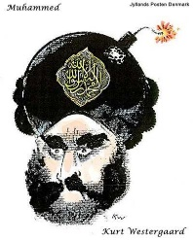

- What bothered the Muslim population in this caricature?

- Is it even possible to come to terms with someone, who doesn’t share the same customs, values, and traditions?

