NAETINEM, Erasmus+ Project  Educational Activity  Toolkit for secondary school teachers | 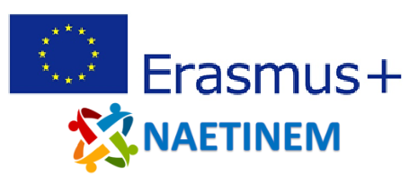

Name of  activity: | Modern Europe and the Congress of Vienna (The Congress of Vienna as the first step to a united Europe?)
Educational  objective: | Students reflect on the event of the Congress of Vienna and draft a value judgment on whether this event can be considered the origin of modern Europe from their point of view.
Qualities in focus: | European history
Target group, age of  the students: | From 14 years (from grade 8)
Suitable for: | European history
Teaching aids,  preparation: | PC, projector, PowerPoint
Time needed: | 45 minutes
Description of  activity: | The students start with a mind map about Europe. In this map, they are asked to collect their associations with Europe. In the following, the students are confronted with various aspects of the Congress of Vienna. The students are asked to reflect on the permanence of the resolutions or the legitimacy of the Congress of Vienna in its time from today's perspective.  With the help of the offered source material (paintings of the Congress of Vienna, Congress of Vienna Acts, maps) the students should formulate answers to the questions.  Based on these questions, the students should formulate a value judgment regarding the Congress of Vienna as the first step to a united Europe.  In the last part of the session, the students' attention is once again drawn to the mind map from the introduction. The students are now asked to reflect on whether the Congress of Vienna should be part of their mind map on Europe or not.  In a final short text, the students are asked to justify their decision.
Created: | 17.10.2021 | Author: | PH Heidelberg
Own  reflections: | Students will reflect on the Congress of Vienna as part of their conception and narrative of a modern Europe. At the end of the session, students will make a value judgement on whether they would like to include the Congress of Vienna in their idea or narrative of Europe.
Enclosures: | NAETINEM_Congress_of_Vienna_1_EN.pptx

