NAETINEM, Erasmus+ Project  Educational Activity  Toolkit for secondary school teachers | 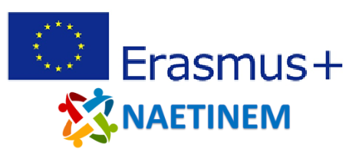

Name of  activity: | Modern Europe and the Congress of Vienna (The Congress of Vienna as the first step to a united Europe?)
Educational  objective: | Students reflect on the event of the Congress of Vienna and draft a value judgment on whether this event can be considered the origin of modern Europe from their point of view.
Qualities in focus: | European history
Target group, age of  the students: | From 14 years (from grade 8)
Suitable for: | European history
Teaching aids,  preparation: | PC, projector, PowerPoint
Time needed: | 45 minutes
Description of  activity: | At the beginning of the unit, students are asked to recall and briefly write down their judgment on the legitimacy of the decisions of the Congress of Vienna from the previous unit.  In the following sequences, the students are confronted with contemporary perspectives on the Congress of Vienna. These are selected from multiple perspectives of participants in the Congress and reactions from the public, who perceive and describe the event differently.  Based on the questions posed, the students reflect on the sources offered and use methodological skills.  Finally, the students are confronted with two contemporary assessments of the Congress of Vienna. The students will be made aware of the retrospective character of such assessments.  At the end of the unit, the students are asked to position themselves based on a speech on the central question "The Congress of Vienna as the first step towards a united Europe?" and to refer to the content they have worked on so far, but also to the arguments of the previous speakers. On the basis of the speech, the students will answer the question posed at the beginning.
Created: | 07.11.2021 | Author: | PH Heidelberg
Own  reflections: | Students will reflect on the Congress of Vienna as part of their vision and narrative of a modern Europe and take a position on the contemporary significance of the event.
Enclosures: | NAETINEM_Congress_of_Vienna_2_EN.pptx

