NAETINEM, Erasmus+ Project  Educational Activity  Toolkit for secondary school teachers | 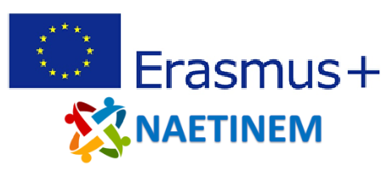

Name of  activity: | The relevance of the motives for European unification today
Educational  objective: | Students will learn about the motives of European unification and reflect on its relevance today and its presence in collective memory.
Qualities in focus:
Target group, age of  the students: | From 16 years (from grade 10)
Suitable for: | European Union today
Teaching aids,  preparation: | PC, projector, PowerPoint
Time needed: | 45 minutes
Description of  activity: | The students start the lesson with a brainstorming session in which they think about the presence of the EU in their everyday life. The suggestions are collected on a mind map. The mind map is used again at the end of the unit.  In the following, the students are provided with short information texts on the motives of European unification for the purpose of contextualization. The students give short headings to the respective sections, which should summarize the described motive in brief words. In a short discussion the students have to negotiate common terms for the respective motives.  In a subsequent discussion, the current relevance of the developed motives should be discussed and ranked. The current relevance of the possible orientation function will be questioned - what was perceived as relevant at the time of unification does not necessarily have to assume this status today.  Finally, the students should compare the motives for founding the EU with their mind map. Here, students should reflect on which motives are part of the collective memory in society (or in their class) and which are not. Based on the thoughts about the current relevance of the motives that have already been made in advance, the students should negotiate which motives they would like to add to their mind map or not. This should also be done in a process of negotiation within the class.
Created: | 06.11.2021 | Author: | PH Heidelberg
Own  reflections: | Students reflect on the relevance of the motives of the foundation of the EU and question the collective memory regarding this event.
Enclosures: | NAETINEM_European_motives_1_EN.pptx

