NAETINEM, Erasmus+ Project  Educational Activity  Toolkit for secondary school teachers | 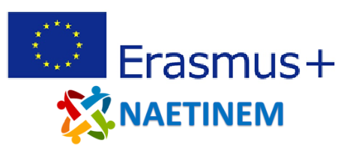

Name of  activity: | Remembering the First World War - Learning Series Part 1
Educational  objective: | Students will visualize different types of memory culture in their environment and reflect on the usefulness of memory sites.
Qualities in focus:
Target group, age of  the students: | From 14 years (from grade 8)
Suitable for: | National and European Remembrance of the First World War.
Teaching aids,  preparation: | PC, projector, PowerPoint, Internet connection (work with padlet.com)
Time needed: | 45 minutes
Description of  activity: | The work process is divided into three blocks of tasks.  In the first task block, a brainstorming session takes place in which the students visualize different forms of memory of the First World War in their environment and become aware of the historical-cultural forms of their environment. The results are visualized using a padlet (padlet.com) and can be compared and ideas exchanged. Depending on the results, this can lead to a discussion of what all can be counted as a form of memory.  In the second block of tasks, the students receive a short information text about memory cultures and places in Europe. On the basis of the questions, the students consider the advantages and disadvantages of various given places of remembrance of the First World War in Europe. Afterwards, they are asked to come up with suggestions for improving one of the sites they have chosen. On the basis of this task, the students ask themselves to what extent the places of remembrance can take on an orientation function in their living environment, or how the places would have to be redesigned in order to fulfill this function.  In the last part of the assignment, the students are confronted with the question of whether they consider the remembrance of wars or the First World War to be meaningful. In a statement, the students are asked to express their opinion and to create a short value judgement regarding remembrance.
Created: | 05.11.2021 | Author: | PH Heidelberg
Own  reflections: | The students become aware of historical-cultural forms of remembrance in their environment. The students reflect on the advantages and disadvantages of certain forms of remembrance with regard to their offer of orientation in the present and, at the end of the unit, draft a value judgment that relates to the fundamental remembrance of wars.
Enclosures: | NAETINEM_Remember_Learning_Series_1_EN.pptx

