NAETINEM, Erasmus+ Project  Educational Activity  Toolkit for secondary school teachers | 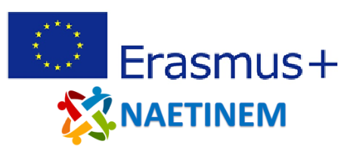

Name of activity: | Remembering the First World War - Learning Series Part 3
Educational  objective: | Students will learn about France's current approach to the memory of the First World War and reflect on it and the possibility of transnational remembrance.
Qualities in focus:
Target group, age of the students: | From 14 years (from grade 8)
Suitable for: | National and Transnational Remembrance of the First World War.
Teaching aids,  preparation: | PC, projector, PowerPoint
Time needed: | 45 minutes
Description of  activity: | The students will be informed about the further course of the learning offer by means of an introductory slide. In the following sessions, the students will deal with the culture of remembrance of different nations.  At the beginning of the assignment, the students are asked to use the Internet to find out about the speech of the French President commemorating the armistice 100 years ago. Students are asked to take notes on the narrative patterns they discover during their research and then compare and discuss their findings. Furthermore, the students should write a diary entry in their role as spectators of the commemoration and present it to their group in order to be able to give each other feedback.  Afterwards, the students should first look at a contemporary cartoon from France that was published on the decision of the Treaty of Versailles. In the following assignments, the students should try to describe this cartoon and interpret its content. Finally, the students should deal with current images of Macron and Merkel or Steinmeier by visualizing the effect of the circumstances of these persons. An exchange in the group about the insights gained should take place in order to write a diary entry in the last assignment. In this diary entry, the students should reflect on the importance of Franco-German friendship from Macron's point of view.
Created: | 06.11.2021 | Author: | PH Heidelberg
Own  reflections: | The students recognize that an event can have a different significance in the culture of remembrance of a nation. The students will be confronted with different perspectives of France's memory of the First World War and position themselves with regard to the importance of Franco-German friendship.
Enclosures: | NAETINEM_Remember_Learning_Series_3_EN.pptx

