NAETINEM, Erasmus+ Project  Educational Activity  Toolkit for secondary school teachers | 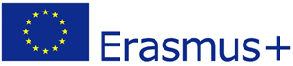  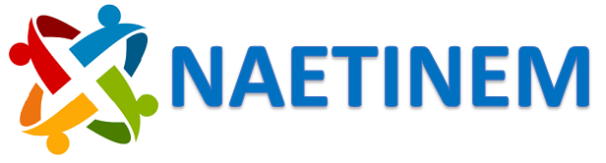

Name of activity: | National Identity and Curative Spas in Slovakia
Educational objective: | Acquainting the students with curative spas in Slovakia
Qualities in focus: |  | National identity and culture
Target group, age of the students: |  | 14–15 years of age
Suitable for: |  | National History ,Geography and Civics
Teaching aids, preparation: | Pictures, videos, cultural sources
Time needed: | 1 unit (45 minutes)
Description of activity: | At the beginning of the lesson, we will briefly explain the roles of Curative waters abound in Slovakia: water heavy in therapeutic minerals, thermal springs and delicious mountain sources.  Each spa location features water specific to one or more health conditions, but each tends to draw the general public as well. Hotels in the area welcome those who wish to stay longer, and to take advantage of complete treatments, but day visitors also enjoy coming to bathe, to drink the waters and just to relax in the lovely surroundings.  We can present individual spas on the attached videos and pictorial materials. The lecture will be conducted in English and we assume that the topic is appropriately designed for students who speak English. We can also provide a Slovak version of the text for Slovak language holders. We can encourage students to talk about Slovak national identity and Slovak spas.  The last part of unit represents a feedback test, which determines the level of acquired knowledge.
Created: | 31.05.2022 |  | Author: | PhDr. Elena Vallová, PhD.
Own reflections: | At the beginning of the lesson, we will briefly explain the function of spas in general and the impact on the national identity of the individual nations that live in each current state. From the point of view of history, we will highlight how individual spas in Slovakia were formed and created. We will outline their connection with the Slovak culture and identity of the Slovak nation. We can present individual spas on the attached videos and pictorial materials. The lecture will be conducted in English and we assume that the topic is appropriately designed for students who speak English. We can also provide a Slovak version of the text for Slovak language holders. We can encourage students to talk about Slovak national identity and Slovak spas.
Enclosures: | Presentation (.ppt), pictures (.jpg)  https://www.slovakia.com/spas/

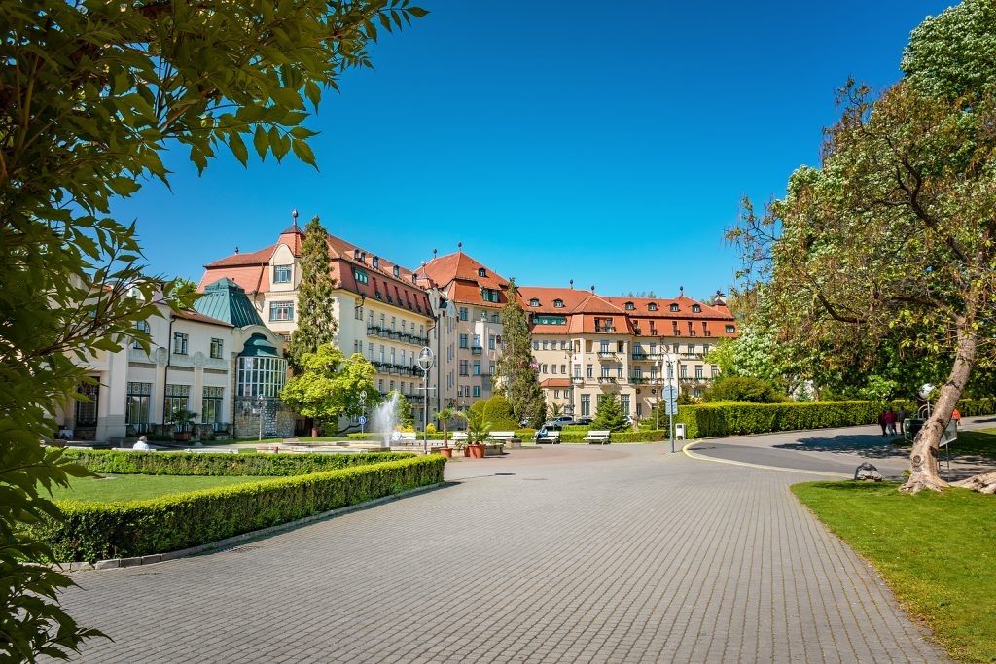

Piešťany Spa

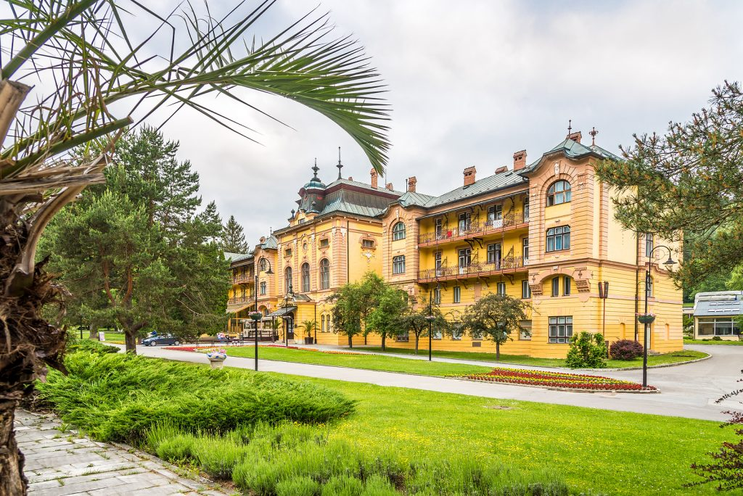

Bardejov Spa

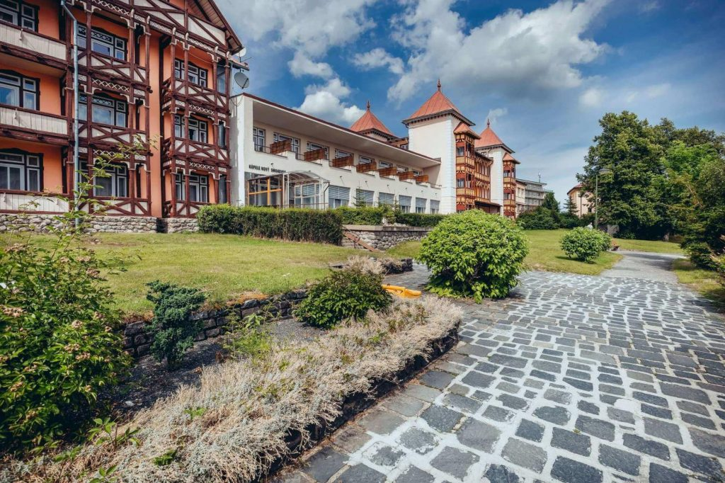

Nový Smokovec Spa

