#### Battlefield Writers of World War I

## World War I, (WW1), also known as the First World War or the Great War, was an international conflict that began on 28 July 1914 and ended on 11 November 1918. It involved much of Europe, as well as Russia, the United States and Turkey, and was also fought in the Middle East, Africa and parts of Asia. One of the deadliest conflicts in history, an estimated 9 million were killed in combat, while over 5 million civilians died from occupation, bombardment, hunger or disease.

## The 1919 *Paris Peace Conference* imposed various settlements on the defeated powers, the best known being the Treaty of Versailles. The dissolution of the Russian, German, Ottoman and Austro-Hungarian empires led to numerous uprisings and the creation of independent states, including Poland, Czechoslovakia and Yugoslavia. For reasons that are still debated, failure to manage the instability that resulted from this upheaval during the interwar period ended with the outbreak of World War II in 1939.

## Impact on Literature

## The war that was originally expected to be “over by Christmas,” dragged on for four years with a grim brutality brought on by the dawn of trench warfare and advanced weapons, including chemical weapons. The horrors of that conflict altered the world for decades—and writers reflected that shifted outlook in their work. As writer Virginia Woolf would later write, “*Then suddenly, like a chasm in a smooth road, the war came*.”

## Early Works Glorified the War

## Among the first to document the “chasm” of the war were soldiers themselves. At first, idealism persisted as leaders glorified young soldiers marching off for the good of the country. English poet Rupert Brooke, after enlisting in Britain’s Royal Navy, wrote a series of patriotic sonnets, including *The Soldier,* which read:

## “*If I should die, think only this of me: That there’s some corner of a foreign field That is for ever England*.”

## Brooke, after being deployed in the Allied invasion of Gallipoli, would die of blood poisoning in 1915.

## In 1915, Canadian doctor Lieutenant-Colonel John McCrae, upon seeing how red poppies grew in the fields that had been ravaged by bombs and littered with bodies, wrote *In Flanders Fields.* The poem, memorializing the death of his friend and fellow soldier, would later be used by Allied militaries to recruit soldiers and raise money in selling war bonds:

## *“In Flanders fields the poppies blow*

## *Between the crosses, row on row,*

## *That mark our place, and in the sky,*

## *The larks, still bravely singing, fly,*

## *Scarce heard amid the guns below.”*

## Literary Tone Shifts after Gruelling WWI Combat

## While both Brooke’s and McCrae’s works lent patriotic tones to the sacrifices of war early in the conflict, as time wore on, the war’s relentless horrors spawned darker reflections. Some, like English poet Wilfred Owen, saw it their duty to reflect the grim reality of the war in their work.

## As Owen would write, “*All a poet today can do is warn. That is why the true poet must be truthful.” In “Anthem for the Doomed Youth,” Owen describes soldiers who “die as cattle” and the “monstrous anger of the guns*.”

## From the opposite side of the firing lines, German writer Erich Maria Remarque also experienced the grim day-to-day life of a soldier. Later, in 1929, he published an unflinching account in his novel, *All Quiet on the Western Front*.

## Among other prominent works, reflecting the horrific realities of war was the four-part tome, *Parade’s End*, by English novelist Ford Madox Ford, and from the Eastern Front, *Dr. Zhivago* by Soviet Russian writer Boris Pasternak, in which the main character describes grotesque injuries inflicted on the war’s battlefields.

## WW1 devastated continents, leaving some millions dead. However, writers responded with profound and ground-breaking work as they and the rest of the world grappled with the war’s upheaval.

## Chosen Battlefield novelists

## In one of the most famous works, set during the WW1 American writer Ernest Hemingway offers a gripping love story between a soldier and a nurse set against the chaotic, stark backdrop of World War I. *A Farewell to Arms* is among the writer’s most autobiographical: Hemingway himself served as an ambulance driver during the war, was severely wounded on the Austro-Italian front and had been sent to a hospital in Milan, where he fell in love with a nurse.

## Author Ernest Hemingway in Italy, April 1919, after being seriously wounded during World War One. (Credit: The Library of Congress/Popperfoto/Getty Images)

*Ernest Hemingway in Italy, April 1919, after being seriously wounded during World War I.*

*(Source: The Library of Congress/Popperfoto/Getty Images)*

Remarque wrote in ***All Quiet on the Western Front***: “*All these things that now, while we are still in the war, sink down in us like a stone, after the war shall waken again, and then shall begin the disentanglement of life and death*.”

## 

## Virginia Woolf, who had been a close friend of the fallen poet Rupert Brooke, wove profound references to the war’s effects throughout her works. In the setting of her acclaimed novel *Mrs. Dalloway*, the war has ended, but everyone remains deeply affected by it, including one of the novel’s main characters, a veteran with severe shell shock (now known as post-traumatic stress disorder).

## Virginia Woolf. (Credit: Culture Club/Getty Images)

*Virginia Woolf. (Source: Culture Club/Getty Images)*

## The disillusionment that grew out of the war contributed to the emergence of modernism, a genre which broke with traditional ways of writing, discarded romantic views of nature and focused on the interior world of characters.

## Woolf’s novels reflected this emerging tone, as did the works of Joseph Conrad (*Heart of Darkness*) and James Joyce (*Ulysses*). T. S. Eliot’s *The Waste Land*, considered to be one of the most significant poems of the 20th century, presents a haunting vision of post-war society, with the opening lines:

## *“April is the cruellest month, breeding*

## *Lilacs out of the dead land, mixing*

## *Memory and desire, stirring*

## *Dull roots with spring rain.”*

## Erich Maria Remarque

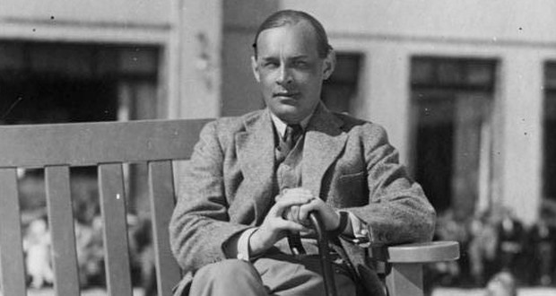

*E. M. Remarque. (Source:<https://www.studentpoint.cz/co-jste-nevedeli-o-remarquovi/>)*

**Erich Maria Remarque**, pseudonym of Erich Paul Remark, was a German pacifist writer who wrote many works about the horrors of war.

His best-known novel is ***All Quiet on the Western Front***(*Im Westen nichts Neues*, 1928), a book about German soldiers in WW1 that later served as the basis for an Oscar-winning film. His pacifism and anti-war stance made him an enemy of the Nazi regime. This novel became perhaps the best-known and most representative novel dealing with WW1.  The intention of the book and partly its content is expressed by its motto "*The book is an attempt to give an account of a generation that was destroyed by war - even though it escaped its shells*". The narrator, Bäumer, tells of his wartime experiences and the hardships the war caused them.

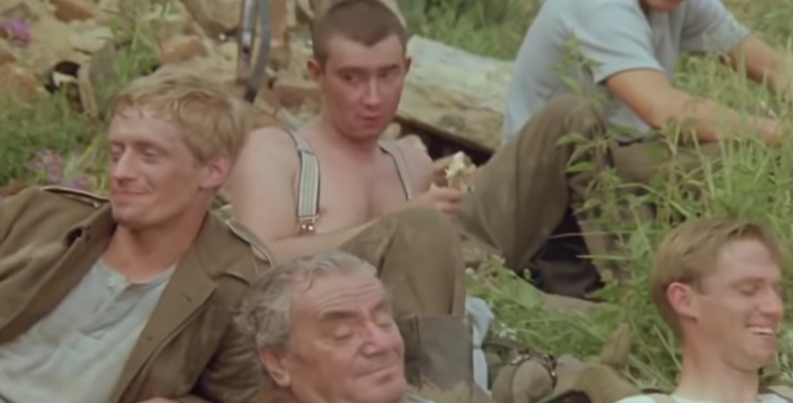

Watch the basic story and characters of the novel:

<https://www.youtube.com/watch?v=puXIQqGBuPI&ab_channel=TrailerChan>

## All Quiet on the Western Front | Locksands Life

## *From the novel All Quiet on the Western Front. (Source: https://locksands.wordpress.com/2015/12/04/all-quiet-on-the-western-front/)*

## Chosen Battlefield poets

**John McCrae**

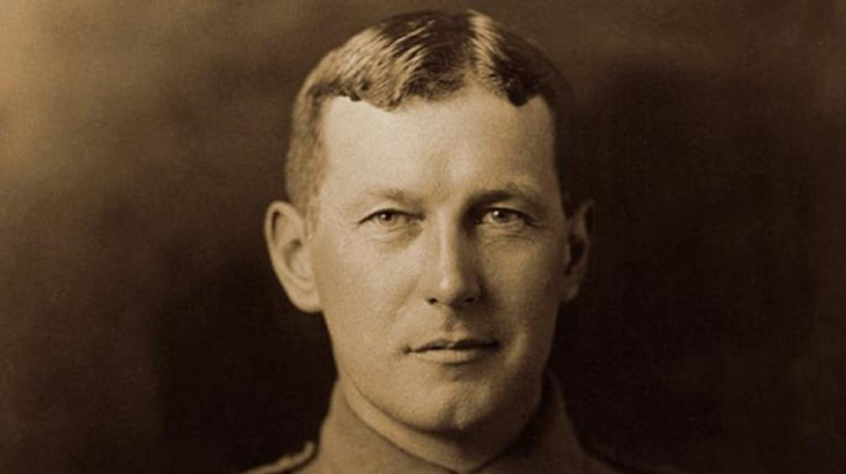

*John McCrae. (Source: Public Domain)*

A doctor by trade, Canada’s **John McCrae** volunteered for WW1 in 1914 and served as a brigade surgeon for an artillery unit. The following year, he had a front row seat to the horrors of the Second Battle of Ypres, where the Germans launched an assault that included the war’s first use of poisonous chlorine gas.

While tending to the wounded and mourning the dead—who included his good friend, Alexis Helmer—McCrae put pen to paper on ***In Flanders Fields***, a poem written from the point of view of fallen soldiers whose graves are overgrown with wild poppy flowers. John McCrae died from pneumonia and meningitis in 1918, but not before the poem became one of WW1’s most popular and widely quoted works of literature. Among other things, it inspired the use of the poppy as the “flower of remembrance” for the war dead.

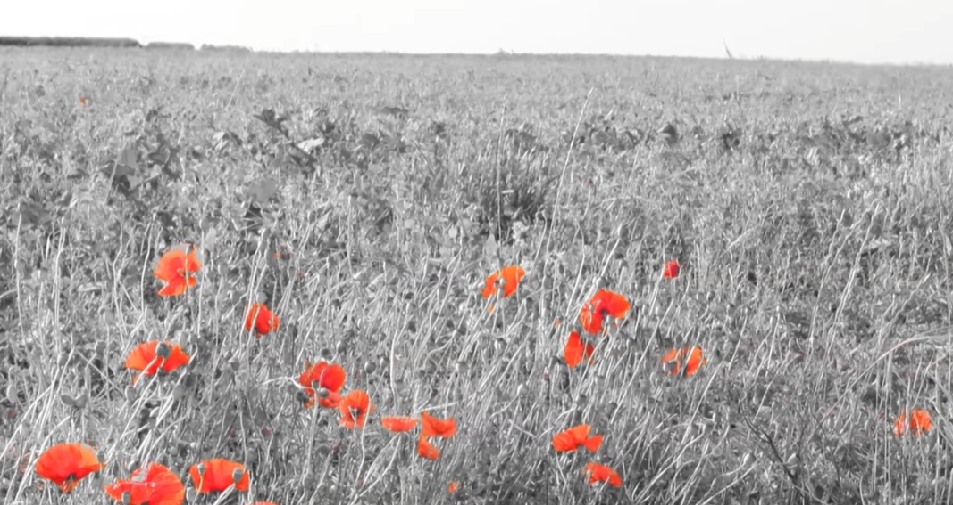

Watch and listen *In Flanders Fields,* the poem by **Siegfied Sassoon**, recited by Leonard Cohen: <https://www.youtube.com/watch?v=cKoJvHcMLfc&ab_channel=LegionMagazine>

IN FLANDERS FIELDS

[[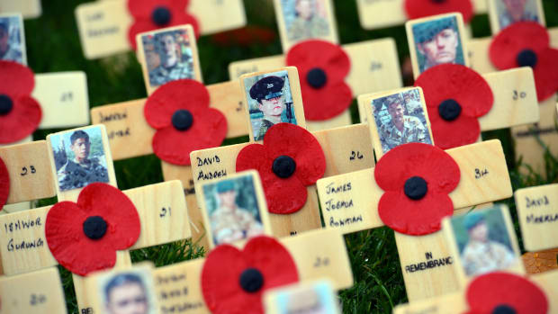](https://www.history.com/news/world-war-i-poppy-remembrance-symbol-veterans-day)](https://www.history.com/news/world-war-i-poppy-remembrance-symbol-veterans-day" \o "The WWI Origins of the Poppy as a Remembrance Symbol)

**by John McCrae**

In Flanders Fields, the poppies blow  
Between the crosses, row on row,  
That mark our place; and in the sky  
The larks, still bravely singing, fly  
Scarce heard amid the guns below.  
  
We are the dead. Short days ago  
We lived, felt dawn, saw sunset glow,  
Loved and were loved, and now we lie,  
In Flanders fields.  
  
Take up our quarrel with the foe:  
To you from failing hands we throw  
The torch; be yours to hold it high.  
If ye break faith with us who die  
We shall not sleep, though poppies grow

In Flanders fields.

**Wilfred Owen**

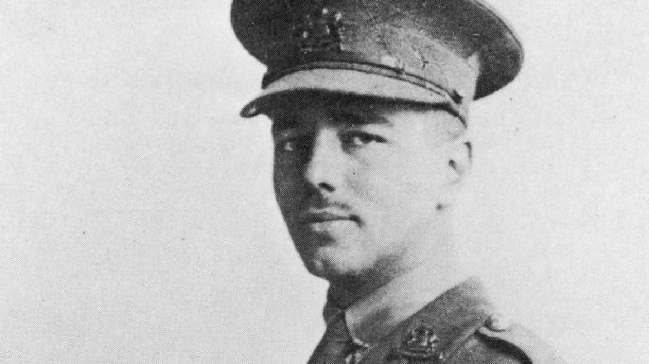

*Wilfred Owen. (Sourcet: Fotosearch/Getty Images)*

Wilfred Owen only published five poems during his lifetime, but his harrowing descriptions of combat have since made him into one of the towering figures of WW1 literature. Just 21 years old when the war broke out, he enlisted in the British army in 1915 and later took part in heavy fighting in France. “I have not been at the front,” he wrote his mother. “I have been in front of it.” After being diagnosed with shellshock in 1917, Owen was sent to convalesce at a hospital in Scotland.

He soon began writing about his experiences at the urging of fellow poet Siegfried Sassoon, and by 1918 he had produced several now-famous works including ***Anthem for Doomed Youth****,* ***Strange Meeting*** and ***Dulce et Decorum Est***, which describes a gas attack in grim detail. Despite his increased opposition to the war—he described soldiers being sent to “die as cattle”. Owen returned to the front lines in August 1918 and was later killed while leading men across a canal in France. His mother received notice of his death on November 11, 1918—the same day that World War I finally came to an end.

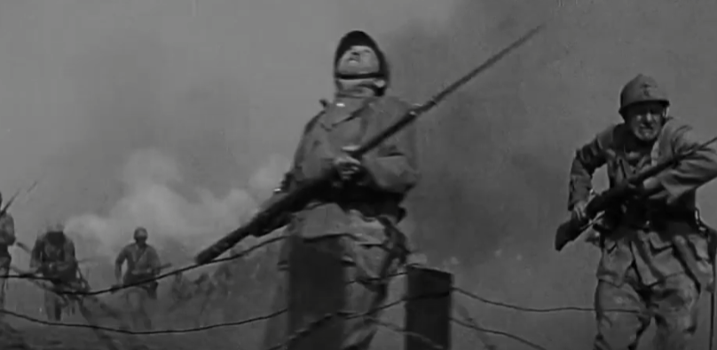

Watch and listen the poem *Anthem for Doomed Youth*, by Wilfred Owen: <https://www.youtube.com/watch?v=LfuxZoy4pLM&ab_channel=eightynineMedia>

## Siegfried Sassoon

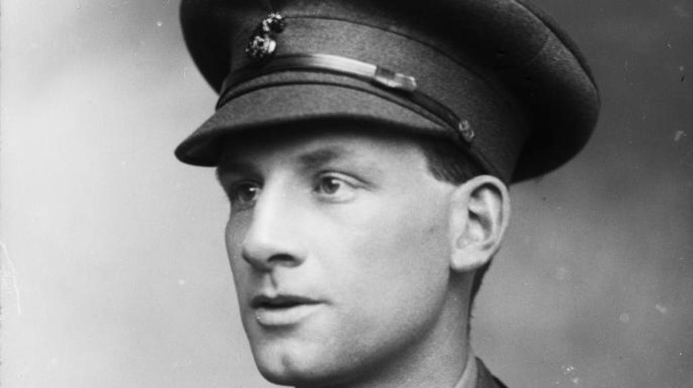

*Siegfried Sassoon. (Source: George C. Beresford/Hulton Archive/Getty Images)*

Soldier-poet Siegfried Sassoon was twice decorated for heroism and earned the nickname “Mad Jack” for his suicidal courage on the battlefield, but he was also one of the most impassioned critics of the savagery and waste of World War I.

In popular works such as ***Attack***, ***The General*** and ***Atrocities***, the British-born aristocrat satirized the conflict’s leaders and described his combat experiences in searing detail. He even flirted with a court-martial by publishing a 1917 letter in which he branded the war “evil and unjust,” but avoided punishment after fellow poet Robert Graves argued that he was suffering from shellshock. Sassoon would eventually write some 100 anti-war poems before being wounded in the head and removed from active duty in 1918. After surviving the war, he went on to a long career as a poet, novelist and lecturer.

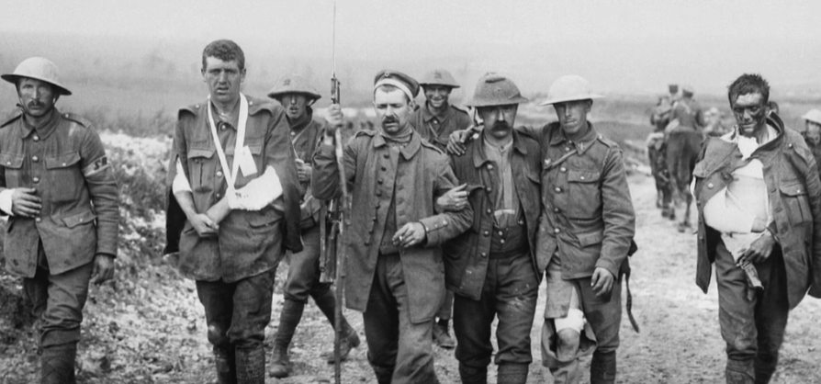

Watch and listen *Does It Matter?,* the poem by Siegfied Sassoon: <https://www.youtube.com/watch?v=NWFdX_-WqMc&ab_channel=BlueSkyMotivation>

## Alan Seeger

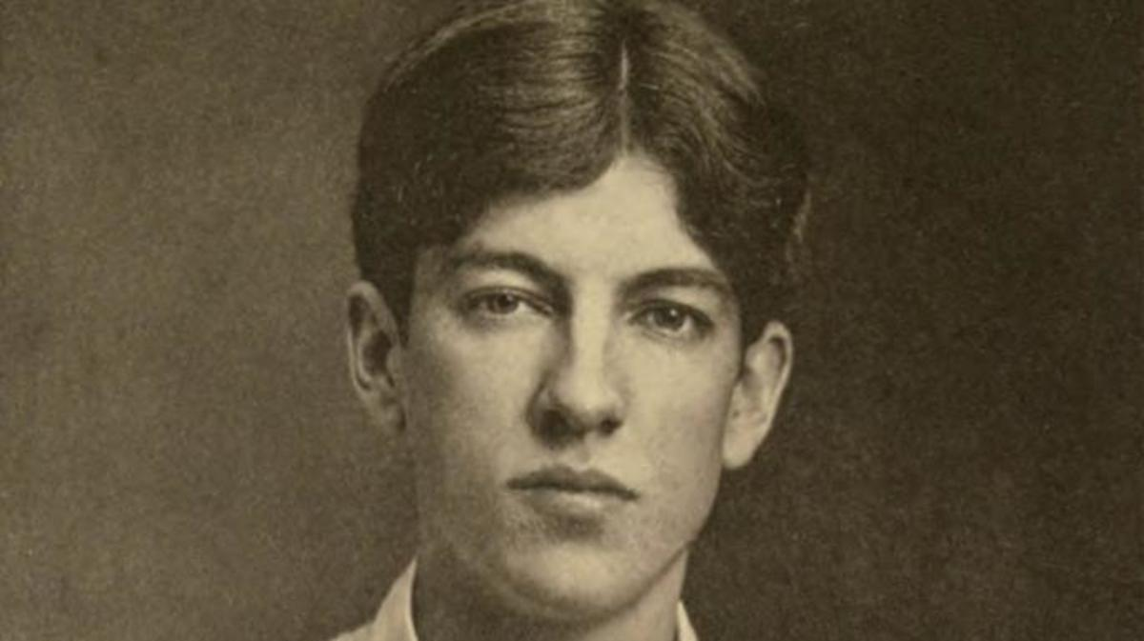

*Alan Seeger. (Sourcet: Public Domain)*

In August 1914, poet Alan Seeger joined the French Foreign Legion and took up a post on the Western Front.

The New York native wrote several works over the next two years including ***Ode in Memory of the American Volunteers Fallen for France***, but he is best known for ***I Have a Rendezvous With Death***, a haunting poem that describes a meeting with a personified Death, “*At some disputed barricade / When Spring comes back with rustling shade*.” Seeger’s own rendezvous with death came on July 4, 1916, when he was mortally wounded in the stomach during an assault on the French village of Belloy-en-Santerre. His only collections of poems debuted the following year, and he’s since become one of the war’s most widely quoted American writers. One notable admirer was President John F. Kennedy, who supposedly listed *Rendezvous* among his favorite poems.

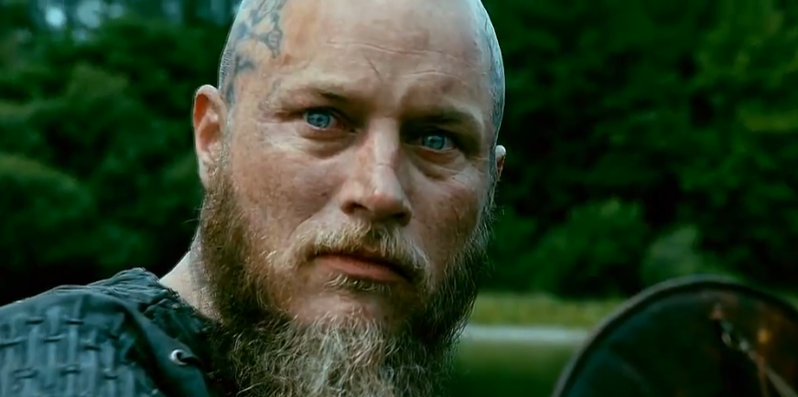

Watch and listen the most known poem by Alan Seeger:

<https://www.youtube.com/watch?v=LATJ8O1cERc&ab_channel=MorphingReality>

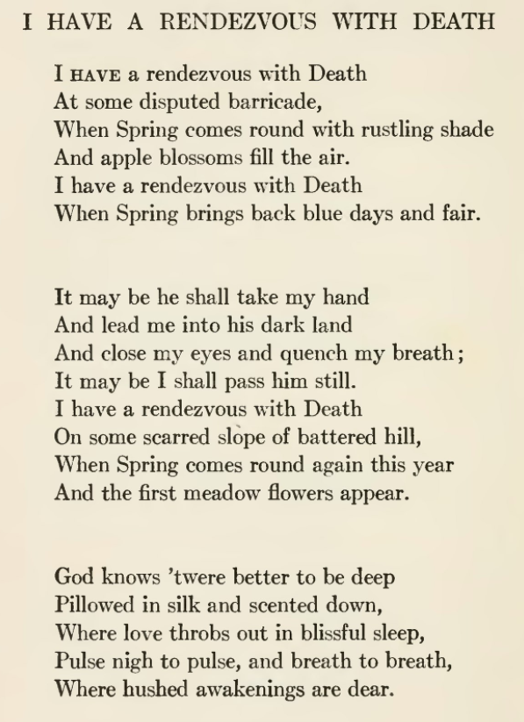

**August Stramm**

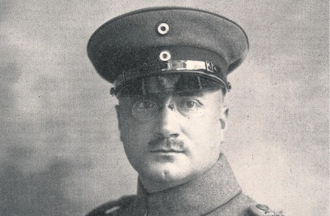

*August Stram, (Source: credit:* [*https://www.poetryfoundation.org/poets/august-stramm*](https://www.poetryfoundation.org/poets/august-stramm)*)*

Most of the best-known WW1 poets fought for Allies, but there were also several talented writers who served with the Central Powers nations. Perhaps the most influential was August Stramm, a German officer who is now considered a pioneer in the **Expressionist movement**.

Stramm fought in dozens of battles across both the Eastern and Western fronts, and he captured the primal nature of warfare in short, staccato poems that often feature abstract imagery and one or two-word lines. “*A star frightens the steeple cross,” reads one work titled “Guard-Duty*.” “*A horse grasps smoke / iron clanks drowsily/ mists spread / fears / staring shivering / shivering*.” Stramm’s courage under fire won him the Iron Cross in early 1915, but he was killed later that year during hand-to-hand fighting in Eastern Europe. His war poetry was published posthumously in 1919 under the title ***Dripping Blood.***

### ***War (Krieg) von August Stramm***

This poem consists of ontological metaphors, or more precisely, personification, where source domain is a human being, person and in terms of this domain target domain such as emotion (Wehe), activities and states and their products (Harren, Kreißen, Bären, Tod, Frage) and time (Zeit, Stunde) are structured.   
 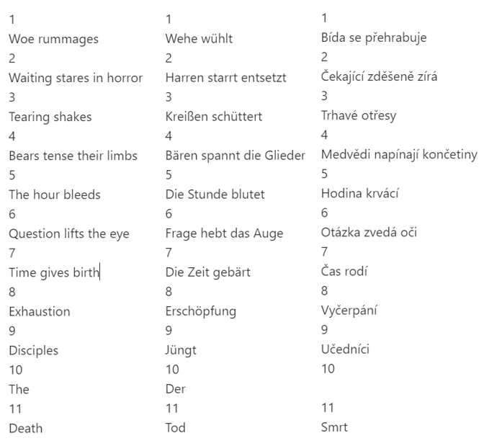

Watch and listen the poem WAR:

<https://www.youtube.com/watch?v=oilgg6mAeAU&list=PLpxfELh1vHytbkzLpmW3W0I6MjQ2lb-uA&index=4&ab_channel=Leitmotivation>

**Tasks:**

1) What is the theme of the poem?

2) What does the poem describe – an experience, a season, or a specific time?

3) What mood does it evoke in you?

4) What is the connection between the title and the poem?

5) Who is speaking in the poem? How can you tell?

6) Which verb tense is used – past, present, future?

7) Are there questions in the poem that remain unanswered?

8) Is the poem (form, language, content and message) still meaningful from today's perspective?

**Sources:**

* <https://www.history.com/news/8-battlefield-poets-of-world-war-i> <https://www.iwm.org.uk/history/9-poets-of-the-first-world-war>
* <https://www.history.com/topics/world-war-i/world-war-i-history>
* <https://www.britannica.com/biography/Erich-Maria-Remarque>
* <https://www.researchgate.net/publication/292894083_Metaphorical_concepts_in_August_Stramm's_poetry>